The 5 RIRs and Their Regions:
# Source: Chatgpt (GPT‑5 Mini) at [12/15/2025]
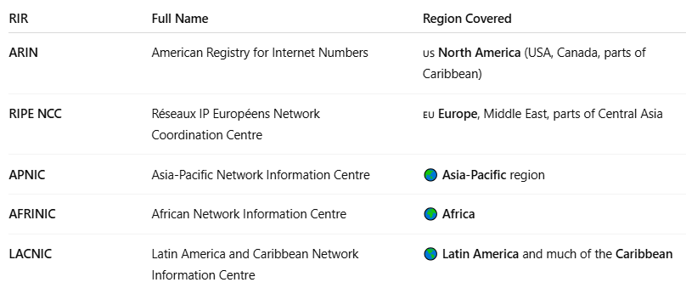

RIR | Full Name | Region Covered
ARIN | American Registry for Internet Numbers | 🇺🇸 North America (USA, Canada, parts of Caribbean)
RIPE NCC | Réseaux IP Européens Network Coordination Centre | 🇪🇺 Europe, Middle East, parts of Central Asia
APNIC | Asia-Pacific Network Information Centre | 🌏 Asia-Pacific region
AFRINIC | African Network Information Centre | 🌍 Africa
LACNIC | Latin America and Caribbean Network Information Centre | 🌎 Latin America and much of the Caribbean

